|  |  |
| --- | --- |
| **Taipei Fine Arts Museum Press Release**  **FOR IMMEDIATE RELEASE**  **Media contact:**  Daisy Shiou, TFAM ([daisy.s-tfam@gov.taipei](mailto:daisy.s-tfam@gov.taipei)) Jean Tzu-chin Kao, TFAM (tckao-tfam@gov.taipei) | TB Website: https://www.taipeibiennial.org  TB23 Website: https://www.taipeibiennial.org/2023  Facebook/Instagram: Taipei Fine Arts Museum    Press Kit |

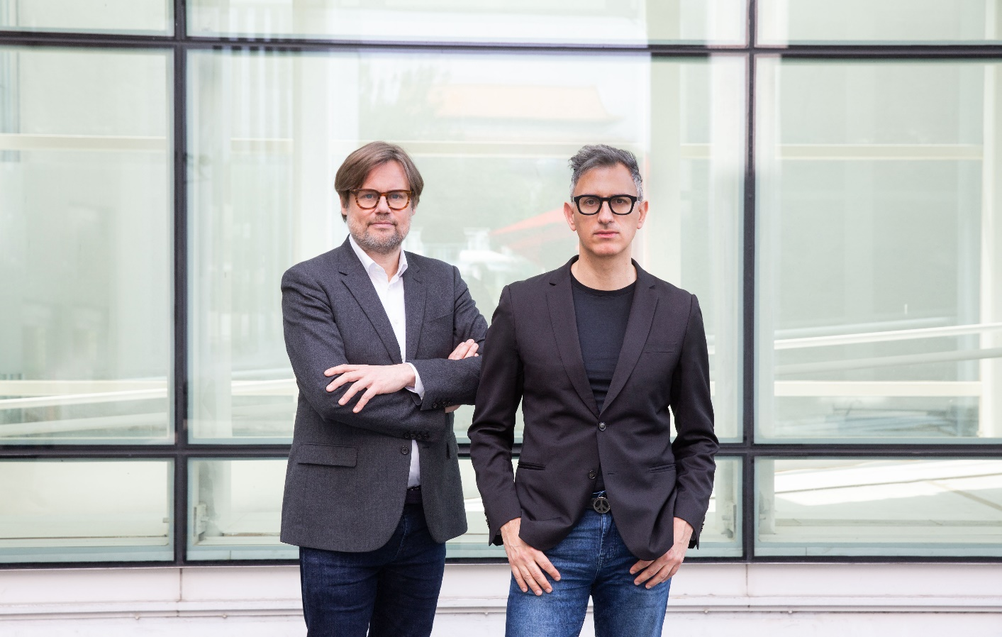

**Taipei Biennial celebrates another successful edition**

**and announces curators for the 14th edition**

**25 March 2024, Taipei ––**The 13th Taipei Biennial: *Small World*, hosted by the Taipei Fine Arts Museum (TFAM), closed with great success last weekend. As the biennial draws to a close, TFAM is delighted to announce that the 14th Taipei Biennial, opening in November 2025, will be curated by **Sam Bardaouil** and **Till Fellrath**. Bardaouil and Fellrath state, “The Taipei Biennial is one of Asia’s most influential and longstanding art events, and we have been closely following its program for many years. In line with our ongoing commitment, our curatorial approach will prioritize the artists, allowing their voices to continuously broaden our understanding of the complex worlds we inhabit. We look forward to bridging our global network to the 14th edition in 2025.”

With a professional background in art history, theatre, economics, and political science, the Lebanese-German curatorial duo are known for their pluri-disciplinary, multi-cultural curatorial practice. Their approach to exhibition making is informed by the complex interplay between local and global contexts, with a focus on developing innovative public programs to engage with diverse communities.

Bardaouil and Fellrath currently serve as directors of Hamburger Bahnhof – National Gallery of Contemporary Art in Berlin. Under their curatorial platform “Art Reoriented,” they have collaborated with over 70 museums worldwide. In 2019, they curated the pavilion of the United Arab Emirates at the La Biennale di Venezia, and in 2022, they co-curated the French pavilion, receiving a “Special Mention” Award. Also in 2022, they curated the 16th Lyon Biennale under the title *Manifesto of Fragility*, where they generated widespread resonance and amplified educational outreach by linking artists with institutions from various creative industries, art schools, and production facilities to collaborate on new commissions and site specific installations.

Reflecting on the 13th Taipei Biennial, curators Freya Chou, Reem Shadid, and Brian Kuan Wood transformed the museum into a space of listening, gathering, and improvising, drawing from life experiences and aesthetic perceptions. Through this approach, they addressed topics and issues faced by the contemporary global society, encouraging audiences to reconsider their own situations and contemplate on their relationships with the external world and their positions within it. At the same time, to enrich the thematic website with extended content, the website fully documents the highlights of Music Room's exciting programs and continuously publishes articles related to artists in the "Small World Journal."

Since its opening in November 2023, the biennial ushered in nearly 200,000 visitors. As the pandemic subsided, the museum saw a surge in enthusiastic foreign visitors and received many guided group tour reservations from junior and senior high schools, colleges and universities, private corporations, as well as academic and research institutions. Meanwhile, curators of international biennials and personages from prestigious art institutions also visited the biennial, including the Centre Pompidou (Paris), Tate (London), Queens Museum (New York), Mori Art Museum (Tokyo), Seoul Museum of Art, Gwangju Museum of Art, Singapore Art Museum, and M+ (Hong Kong), among others, highlighting the event’s public nature and international significance.

In addition, this edition garnered much attention worldwide. Several major international art media outlets, such as *Art Review, ArtAsiaPacific*, and *Art Basel Stories,* featured the biennial in their list of must-see exhibitions. Professional art publications and journalists from around the world, including *Frieze* (UK), *Mousse* (Italy), *Artribune* (Italy), *Artlink Australia*, *Canvas* (Dubai), among others, published detailed articles about this edition. Reports and reviews of the biennial also appeared on media platforms engaging in discourses of lifestyle, music, fashion, and social matters, signifying the extensive discussions, imaginations, and resonance sparked by the exhibition.

Meanwhile, TFAM has been proactively facilitating connections between Taiwanese art and the international art community. Throughout the biennial, the museum collaborated with the SculptureCenter in New York to present “Small World Cinema.” Afterwards, the exhibition will also be presented at the Beirut Art Center (BAC) in October later this year, and feature the same topics and themes with adjusted content aimed at promoting cultural exchange and international interaction between Taiwan and the Middle Eastern region.

The Taipei Biennial, launched in 1998, is one of the most long-established biennials in Asia. Building on the foundation of fostering contemporary art in Taiwan, it is anticipated that the forthcoming edition will further cultivate opportunities for interaction and the exchange of ideas among local and international communities. TFAM director Jun-Jieh Wang states, “The 13th Taipei Biennial: *Small World* epitomized the re-organization of our relations with the post-pandemic environment and all those therein. For the upcoming 14th edition, which will run from November 2025 to March 2026, TFAM has extended the preparation period, allowing for a longer intercultural engagement with local communities. This will enable a deeper foray into critical issues that resonate with the role of contemporary art in our world. As the baton is passed on to the curatorial duo of Bardaouil and Fellrath, we envision a platform that transcends national boundaries, and offers enduring reflective dialogues informed by a variety of perspectives and experiences.”

**Curators’ biography**

**Sam Bardaouil and Till Fellrath** are directors of Hamburger Bahnhof – National Gallery of Contemporary Art in Berlin since January 2022. They have collaborated with over 70 museums worldwide through their interdisciplinary curatorial platform Art Reoriented. They were curators of the 16th Lyon Biennale in 2022 under the title *Manifesto of Fragility*. At the Venice Biennale 2022 they were curators of the French pavilion, as well as the pavilions of Lebanon in 2013 and the United Arab Emirates in 2019. In Berlin they were associate curators at the Gropius Bau from 2017 to 2021.

Central to their work is inclusion in artistic and institutional practices, and a revisionist approach to art history. They are award-winning authors who have held teaching positions at various universities including the Tisch School of the Arts at NYU, the Shanghai Academy of Fine Arts, and the Academy of Fine Arts in Nuremberg. Bardaouil, born in Lebanon, holds an MFA in Advanced Theatre Practice and a PhD in Art History. Fellrath, born in Germany, holds two Master’s degrees in Economics and Political Science.

Bardaouil and Fellrath have curated exhibitions and collaborated with renowned institutions worldwide, including Centre Pompidou in Paris, Villa Empain in Brussels, Kunstsammlung NRW in Dusseldorf, Tate Liverpool, ARTER in Istanbul, Gwangju and Busan Museums of Art in South Korea, Saradar Collection in Beirut, Mathaf: Arab Museum of Modern Art in Doha, SCAD Museum of Art in Savannah, Moderna Museet in Stockholm, and Reina Sofia in Madrid.

**About Taipei Biennial**

Being one of the most long-standing biennials in Asia, the Taipei Biennial held by the Taipei Fine Arts Museum has endeavored in driving Taiwanese contemporary art development since it was launched in 1998, facilitating a platform of interaction and exchange between local and international communities through its vigorous engagement informed by diversely cultural perspectives in Asian and global contemporary art networks. Through the multi-directional communication of exhibition mechanism, the biennial aims to proactively lead in discussions and respond to contemporary issues, encompassing global perspectives and regional individuality. In the recent editions, experts and professionals from various disciplines have been invited to participate in the biennial with the objective to spark and introduce multifacetedness of art, while engendering the energy of different artistic dimensions.

<https://www.taipeibiennial.org/>

**About Taipei Fine Arts Museum**

Established in 1983 in response to a burgeoning modern art movement, the Taipei Fine Arts Museum (TFAM) is Taiwan’s first museum of modern and contemporary art. Since its inception, the museum has shouldered its mission dedicated to the preservation, research, development and advocacy of modern art in Taiwan, while staying abreast of cultural productions that arise in the context of an expanding global contemporary art scene. TFAM has been participating in Venice Biennale since 1995 and has been hosting the Taipei Biennial since 1998, inviting renowned international and local curators and artists to participate in the exhibition.

[www.tfam.museum](http://www.tfam.museum)

- END –